**Father Connection & Support in Adulthood**

Chris Soria

University of California Berkeley

Chris.Soria@berkeley.edu

## **Short Abstract**

Despite rapidly expanding interest in fathers, scholars know little about the impact of fathers on adult health and well-being. How does the positive presence – or lack thereof - of fathers in adult children’s lives affect their social networks? Drawing on attachment theory and social capital theory to examine novel UC Berkeley Social Networks Study (UC Nets) data, I seek to extend understanding of how father attachment and socialization can influence adult social well-being. I find that individuals who name a father in their social network have significantly more social ties. Those with a “close” father have larger social networks than those who name a father who is not “close.” This has consequences for individuals’ broader networks: respondents with a “close” father report more males – but not females – in social activities networks. In contrast, having a “close” mother was associated with more females to confide in, but less males.

## **Introduction**

The role of parental involvement in a child’s life is often discussed in terms of the child’s early child and adolescence and launching into adulthood as measured by years of schooling, employment, criminal justice involvement, entry into parenthood and more (Pleck, 2007). All of these pathways can also be connected to the social networks that children develop as they age and enter into adulthood. Fathers are now more involved in their children’s lives than had been the case two generations ago (Livingston, Gretchen, 2011), and studying father involvement is an area of research identified by Hofferth and Goldscheider (Hofferth, Goldscheider, 2015) as a crucial part of a body of family research. Yet the relationship with parents does not end at adulthood. While family solidarity theory has posited that close family relationships are important across the life course (Bengtson, Roberts, 1991), little work has been done to understand the mechanisms underlying affectual solidarity between fathers and their children, and its role in the adult child’s well-being (Sharabany, Scher & GalKruz, 2006). The goal of this paper is to expand understanding on what this impact may look like by observing the social network of adults as an outcome of a close relationship with a father. More specifically, the question asked is: How does the positive presence – or lack thereof - of fathers in adult children’s lives affect their social networks?

The consensus in fatherhood research is that the father is crucial to the socialization and personality development of their children (Lamb, 2010). However, existing literature on father involvement is often limited in that it simply assumes that father involvement is positive without explaining why or how (Pleck, 2007). I argue that it’s important to understand the underlying mechanisms behind these positive outcomes in order to develop theory as well as to understand the mediators of involvement effects which could be analyzed more closely in future research (Palkovitz, 2002). Further, I argue that the individual’s direct and *subjective* experience with her father is a better measure of a positive, or negative, presence than are “objective” measures--such as residency, physical distance, etc.

Although, plenty of research has found that the father’s presence in their child’s life produces positive outcomes, the evidence for a *direct* and/or a *unique* impact on children by the father is scarce (Brown et al., 2009; Mitchel et al., 2007). There is evidence that mothers produce unique outcomes in relation to the father (Belsky, Garduque, Hrncir, 1984; Verscheuren and Marcoen, 1999; Labrell, Deleau, Juhel, 2000; Portu-Zapirain, 2013). However, many have failed to produce evidence of the *father’s* direct impact on their children for the reason that these studies often do not control for the potential indirect impacts caused by his absence or presence by way of factors such as income, education, neighborhood and the mother’s response to his presence/absence (Lamb, 2010). Further, these studies often assume that all children experience the father in the same way or that his residency also implies “presence” (Amato & Rivera, 1999).

This paper seeks to fill this gap by studying the individual’s perception of her father, the quality of his presence, and real-world outcomes on adult respondents.

## **Theoretical Framework**

### Attachment theory

Attachment theory is based on the idea that humans require cooperation and support from others for survival and that certain human behaviors are “programmed” into us through the evolutionary process. Those in our evolutionary history who were able to maintain proximity and connection to others were more likely to survive and reproduce and therefore pass down these behaviors to offspring. If the individual feels “attached” to a figure (loved, secure), he/she is more likely to behave in a confident way, explore their environment and interact with others in their community (Bowlby, 1969, 1980). That is, the attachment figure provides a psychological “secure base” for the individual to fall back on in case of failure out in the “real world” (Bowlby, 1988).

Typically, within research questions, attachment theory is applied to infants; however, attachment behaviors continue to exist throughout the life course. Hazan and Shaver helped pioneer adult-attachment research in 1987 and concluded that adult romantic relationships tend to be driven by similar attachment behaviors as child-parent relationships do (Hazan & Shaver, 1987). Since then, an abundance of research has uncovered evidence for adult attachment (Fraley & Spieker, 2003a, 2003b) and attachment theory has become one of the best empirically supported theories for understanding human behavior (Koen, Kerns, 2018). There is strong evidence that attachment behaviors continue into adulthood, adults continue to seek out attachment in relationships and are positively affected by successful attachment.

Within the framework of attachment behaviors are the process of evolutionary biology and a series of programmed survival mechanisms, it makes sense that *parental figures* as sources of attachment are more significant to children during the formative years--parents are more instrumental towards the survival of their children when they are young. It also makes sense, however, that *adult* children, to a lesser degree, continue to benefit from attachment to their parents. That is, adult children continue to perceive their parents as a “secure base” in which they can return to in case of failure. And so, the *social* benefits that infants receive from having a secure relationship with a parent could also extend to adult children to a degree.

There is evidence, for example, that infants who achieve secure attachment with their parents are more likely to establish relationships with others (Benoit, 2004). If parental attachment continues to be significant for individuals into adulthood, adults who are secure in their relationships with their parents should *also* be more likely to establish relationships with people beyond the parents. Because parental attachment results in higher levels of confidence and exposing oneself to vulnerability, adults who report higher levels of “closeness” with their parents should be more likely to have people in their network who they confide in, socialize with, or ask for advice. Further, because parental attachment provides children with the confidence to explore the “real world,” *adults* who lack attachment to a parent may also be less likely to put themselves in social situations. For these reasons, adults who lack a subjectively “close” parent may have less robust social circles.

Although, attachment from a father figure is often the same as attachment from a mother figure (Main, Weston, 1981; Folco, et al, 2016), there are often differences in the way fathers and mothers interact with their children that can result in different attachment styles (Lamb, 1977; Mackey, 1979; Cowan, Cowan, Pruett, Pruett, 2019). Further, there is evidence that sons and daughters react differently to attachment from their fathers (Braungart-Rieker, Courtney, Garwood, 1999). Therefore, it’s possible that close fathers generate unique outcomes for their adult-sons in comparison to their adult-daughters--the father’s contribution to the family may be “essential.”

In a review of adult attachment literature, Chris Fraley concluded that the “attachment system” of behaviors observed in children continues to influence thought and behavior patterns into adulthood (Fraley & Shaver, 2000). Furthermore, in another paper, Chris Fraley writes about a model for parental attachment which essentially “updates” the individual’s perspectives based on more recent attachment experiences with the parents (Fraley, 2002). His conclusion here, as well as mine, is that parental attachment and its significance in adults is an area which requires further research.

### Social Capital Theory

Social capital theory, generated by J.S. Coleman (1988), operates at the level of the family and involves the passing down of behaviors which promote cognitive-social development-- among other things. It’s a theory that, unlike attachment theory, is based on the individual as a rational actor who is aware of her social resources and who obtains them for her own personal gain. Further, social capital can also be gained subconsciously by individuals by way of belonging to a certain community or by receiving access to some social benefit--such as a neighborhood consisting of people who look after one another. In essence, social capital exists in *relationships*. This theory also posits that children benefit from proximity to their parents by way of sharing in their social networks and by learning how to navigate in the “adult” world from them. The passing down of behaviors is referred to as “parental socialization social capital.” The sharing of social networks/communication on how to navigate the world is referred to as “parental community social capital.”   
 Fatherhood researchers have argued that it’s important to distinguish between these two categories of action within social capital theory due to them occurring at different stages in the child’s lifespan. “Parental socialization capital” is more likely to occur during the child’s infancy whereas “parental community social capital” is more likely to happen as the child turns into an adult. Further, Entwisle and Astone (1994), argue that the parents’ socioeconomic status is more impactful on children during *early* development, whereas parents’ employment status and occupation is more impactful *during* later development (Leydendecker, Harwood, Comparini, Yalcinkaya, 2005). Adult children benefit from access to a parent’s professional ties and skills and are therefore more likely to tap into these resources when they are available--this should be apparent in an individual’s social network size and composition.   
 Social capital theory doesn’t describe in much detail what socialization looks like or why it influences children. However, what the theory *does* posit is that positive engagement and warmth from the parent are both likely to lead to social capital. This process occurs through proximity and direct interaction between the parent and child. That is, every interaction with the father is a learning opportunity for the child and also an opportunity to be introduced to someone in his network. Furthermore, parental network access places children in peer contexts which promote additional, and similar, interactions with others who may also introduce them to others in their network, and so on.  
 I add my own contribution to the theory by arguing that the gender of the parent matters due to the fact that gender creates distinct experiences in “the real world.” Our genders orient us and provide us with a perspective of ourselves and our place in the world. That is, men experience the world differently than women because of the way their gender role interacts with real-world situations, with everyone's expectations of them carrying it out, as well as others’ expectations as to what is acceptable. Respective gender roles are, in many ways, *adaptations* and carry within them behaviors which are functional for traversing life experiences which are unique to men and women (Lipinska-Grobelny, 2011).   
 For example, men are more often tasked with being the “breadwinner” of the family, whereas women are more often tasked with being the primary caretakers of children (Ferman, Buhrmester, 1985; Parker, Wang, 2013; Livingston, 2014). The successful completion of these tasks requires different attitudes, outlooks, and responses to situations (Power & Park, 1983; Harrison & Magill-Evans, 1996). For this reason, it’s likely that fathers may possess unique information on how men, and their gender role, interacts with the “real world.” Therefore, it’s possible that fathers may transmit a qualitatively *different* social capital to their children. That is, fathers pass down information on how children are to navigate the *male* social world according to what fathers deem to be “correct.”   
 Taking both theories into consideration, we should expect that adults who come into contact with their parents more often are likely to have a larger number of people in their social circles. Those who have positive, or “close”relationships with their parents may be more likely to have social capital passed down to them. And, those who perceive the father as a “secure base” may be more likely to venture out and generate further social ties. Further, if it’s true that fathers transmit a *unique* form of social capital to their children, “close” fathers should produce unique associations in relation to “close” mothers.

## **Literature Review**

### Important fathers, or essential?

Current fatherhood research is conflicted between these two opposing hypotheses: the “essential father hypothesis” and the “important father hypothesis.” According to the “Essential Father Hypothesis,”, a father, because of his gender, makes unique contributions that a mother does not. An “important” father, on the other hand, can significantly affect child outcomes but can be “replaced” by a female figure. For example, two mothers would produce the same outcomes in children as would a traditional family. When a father is absent, the child lacks a second parent, but it’s not necessarily his “fatherness” that is important (Lamb, 2010).

From both perspectives, positive father contributions need not come from a biological father. Although step-fathers less often engage in activities which produce positive outcomes than do biological fathers, those positive activities, when they occur, could be just as valuable (King, Thorsen, Amato, 2014). Moreover, in both perspectives, the father effect is *direct*, not explained as the consequence of factors such as his contribution to income (e.g., Biblarz & Raftery, 1999) or influence on the mother (Hannighofer, Foran, Hahlweg, Zimmermann, 2017).

Measuring a direct impact is something that previous empirical literature often doesn’t find due to its focus on whether the father resides within the same household as a measure for presence; fatherhood scholars have argued that this measurement is limited (Lamb, 2010). A father may be a resident and yet not be “present,” while a nonresident father may actually be more “present.” A review of fatherhood research concluded that in 10 of 14 studies involving resident fathers, positive engagement produced positive outcomes in children (Pleck & Masciadrelli, 2004) but positive outcomes are also observed in children when *non-resident* fathers are positively engaged (Amato & Gilbreth, 1999). Although some researchers have failed to find support for positive outcomes as a result of *any* positive father interactions (McBride, Dyer, Liu, Brown, Hong, 2000), that positive outcomes have been observed as a result of both resident and non-resident fathers is evidence that the *quality* of the relationship with the father should be primary, not residency.

Another methodological concern is that father involvement cannot be properly assessed by generalized measures of how much time the father spends with *all* of his children because individual children within the family may experience him differently, for different amounts of time (Amato & Rivera, 1999), in negative as well as positive ways. Studies which have focused on activities rather than on time spent or residency have been better at producing positive correlates with developmental outcomes (Pleck and Masciadrelli, 2004). Also, this is evidence that the best way to measure the quality of a father’s presence is through the *individual’s* experience with him.

Further, it’s possible that the same types of involvement are expressed differently based on the gender of the parent. That is, it’s possible that father warmth more than mother warmth, for example, is significant to children when it manifests itself in the form of seemingly non-warm activities (such as helping the son with practical activities or playing sports with him). This can only be observed by creating separate measures for father warmth and mother warmth and including them in the same analysis. Indeed, it is the case that fathers will tend to express their warmth to other men, even sons, in different ways (Swain, 1989; Wood, Inman, 1993).

Whether father presence continues to influence children into adulthood is another area which lacks investigation. Still, while research on adult father-child relationships is limited (Sharabany, Scher & GalKruz, 2006), available studies suggest that father presence and closeness continue to be important for psychological well-being into young adulthood (Amato, 1994; Barnett, Marshall, Pleck, 1992). And, Edgar Long and others (2014) found that adult sons who describe their relationship with their fathers as “positive” were more likely to adopt similar personalities to their fathers. In other words, there is some evidence to suggest that fathers continue to matter for children well into adulthood.

This study extends the exploration of adult effects to the question of whether the quality of the father relationship affects an adult child’s ability to form and maintain relationships by measurement of the *actual* size and composition of their social networks.

### Parents, kin, and the social network

Personality development and socialization researchers have argued that the father has a unique impact on children and their development. But, how do parents continue to influence their children as they age? When it comes to how the parents fit into the adult’s social network, some work has already been done using the current dataset of my study to answer this question. Shira Offer and Claude Fischer found that young respondents tended to list their parents as sources of emotional support through confiding and advice more often. They also found that respondents were more likely to receive, and provide, emergency support from the mother than the father (Offer, Fischer, 2018).   
 Other research has found that parents tend to influence the social network of their children positively (Rubin, Sloman, 1984), on the other hand; little research has been done on how parents affect the social network of their adult children. However, a meta-analysis of 156 studies found that adult-children during college tended to report higher interpersonal competence and more relationship satisfaction when they had “secure attachment” with their parents (Mattanah, Lopez, Govern, 2011).   
 But, does the quality of the *father* relationship uniquely affect adult children in their ability to form, and maintain, relationships relative to the mother? I could find no studies that have sought to contribute to this question.   
 Given that gender is associated with unique life chances, experiences, and perspectives, it makes sense to believe that the gender of the parent could lead to unique contributions to their children’s lives. For example, men and women’s differing gender roles tend to send them through different life trajectories, which results in differing social network size and composition (Szell, Thurner, 2013). For example, women tend to interact more often with, and have more, family in their social networks (Hogan, Eggeben, Clogg, 1993; Fischer, 1982). In a study of ties as a source of conflict, Ann Leffler found that men and women differ in the size and composition of negative ties in their network. In her analysis, 76% of respondents’ “antagonists” were of the same gender as the respondent, but when looking at women he found that a majority of “irritants” in women’s networks were men. Furthermore, he found that women’s “irritants” were mostly kin whereas most of men’s “irritants” were non-kin (Leffler, Krannich, Gillespie, 1986).   
 Clearly, men and women react differently within the social world. It’s possible that the interaction between the parent’s gender and their parental status will produce unique outcomes. However, it’s not necessarily the case that they will be positive.   
 This paper hopes to contribute to understanding of the father’s continued significance in adult children’s lives and fill the gaps in fatherhood literature by studying people who have “close” relationships with their fathers versus those who don’t. Also, acknowledging the possibility that “difficult” fathers may be negatively associated with the number of ties a respondent has, controls for the presence of such a father are crucial. Lastly, gender-specific models will be necessary in order to find out whether the father generates a unique impact on the social network of individuals by way of being associated with ties of one specific gender more often than another. In order to observe potential unique father impacts on respondents, mothers must be observed in the same analysis.

## **Data & Methodology**

**Data**

The UC Berkeley Social Networks Study, or “UCNets” is a five-year panel study funded by the National Institute on Aging (http://ucnets.berkeley.edu). Responses were collected in 2015 in the first wave of a longitudinal panel survey through address and Facebook-based sampling. The survey collected data on 1159 people in two cohorts – 21-30 year-olds and 50-70 year-olds ii living in the S.F. Bay Area. The surveys/interviews were conducted with some respondents face to face and others online (see documentation on website).

Data on social networks was collected by asking respondents name-eliciting questions on the types of relationships they had. This was done by first asking the respondent how often they engaged in a certain kind of activity and then asking them to provide a list of people they engaged in that activity with. The result was both a count of how many people the respondent engaged in certain kinds of activity with as well as names for identification purposes.

*Father Variables*

Father variables were constructed around three categories of respondents. First, there were people who named a father in their list and also considered him to be subjectively “close.” “Closeness” was determined through an evaluation made of each social tie from previous name eliciting questions. Second, there were people who named their father but did not identify as “close.” Lastly, there were respondents who did not name, a father for whatever reason, but reported that he was alive. This last category represents respondents with an “estranged” father—a father who is alive but not present in their lives. Parallel “close” mother variables were also created.

It’s important to note that a father simply *being named* in the network may be more significant than him being “close” when observing social network outcomes. In other words, a father being named may be associated with a more robust social network while him being considered “close” may not be. There is no assumption of a linear relationship between the three categories (close father, non-close father named, and no father named).

Lastly, the study asks respondents to identify their father as, “anyone they consider to be a father.” Thus, this variable does not only represent biological fathers. Further, because the theory providing the framework for this paper doesn’t require for a father to be biological, I grouped both fathers and the small number of stepfathers reported by respondents into one category. People who reported more than one father or mother in this study were excluded; their reason for stating they had two fathers/mothers was not clear.

*Dependent variables*

Each respondent was asked name-eliciting questions based on what types of activities they engaged in with people in their lives. I used the total amount of people the respondent named as someone they engaged in social activity with, confided in and received advice from to create three respective dependent variables. There were three people in this study who answered the survey but refused to provide any information about their social network for whatever reason. These people were removed from the sample.

Social activities were defined generally as anything “social,” such as hanging out, going to a movie together, going out for drinks, etc. A person to confide in was someone the respondent could talk to about “personal matters,” such as issues with a relationship, important things in life, difficult experiences, etc. An advice giver was someone the respondent would go to for help with important decisions.

Because we were interested in the association between a close parent and the number of people the respondent interacted with *beyond* them, I removed parents from these three lists *if* they were named (social, confiding, and advising). The result was three dependent variables in which all mothers and fathers are removed from social activity lists. These are, then, measures of respondents’ social connections beyond the parents.

Therefore, there are 3 distinct dependent variables (which are analyzed in separate models): the total number of people a respondent engages in social activities with, the number of people a respondent confides in, and the number of people a respondent receives advice from. From these 3, I generated gender specific versions of these lists (*Table 1A*).

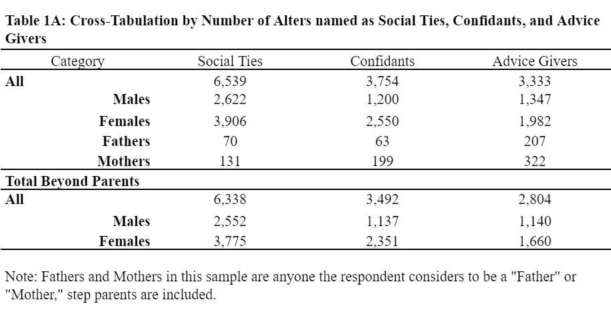

*Covariates*

We controlled for respondent income, gender/sex, education, age and race and whether the father was physically close (within an hour). We decided not to control for a physically close mother due to this category being highly correlated with a physically close father. A previous version of these models controlled for personality characteristics and the respondent’s sexuality; these variable were removed to make the model more parsimonious after discovering that they did not impact the outcome of our primary variables in any significant way.

Various events in life affect the size, and quality, of people’s social networks. For example, getting married has the effect generating new kin ties, but also tends to *reduce* the amount of interaction people spend with kin. Losing a wife/husband tends to have the opposite consequence, where people will tend to lose kin but interact *more* with remaining kin (Gerstel and Sarkisian, 2006; Kalmijn, Graaf, 2012; Guiaux, et al., 2007). For this reason, it’s important to control for such life events in observing the association between a positive, or close, relationship with the father and the ego’s social circle. Lastly, we included variables which may inhibit or influence network size and quality as controls. These included events like a recent new job and/or a new baby (Wruz, et al, 2013).

Initially, I had planned to use advice giving fathers and fathers the respondent had available to confide in as controls. However, a structure matrix, using an Oblimin with Kaiser normalization rotation method, showed that close, confidant, and advice-giving fathers were closely related enough to be measuring a similar concept. We decided to eliminate both confidant and advice-giving fathers and focus solely on the subjective “close” father in order to avoid potential issues with multicollinearity.

**Methods**

Because of categorical independent variables, I used an SPSS General Linear Model (GLM) (also known as UNIANOVA) instead of a normal linear regression due to its ability to incorporate categorical and continuous variables into one output easily. This model is, however, mathematically similar to a linear regression. Essentially, this model takes the highest numbered category and treats it as the reference category to compare to each category below it independently (2 compared to 1 and 2 compared to 0). Effectively, this converts the categorical variable into two dummy variables. In more concrete terms, this model will allow us to observe whether having a father in the network is significant in producing a more robust social network or whether he must also be “close.”

It’s important to mention that these models were designed around the father. I selected for respondents who reported having a *father* who was alive and controlled for the *father’s* distance from the respondent, the same was not done for mothers. Thus, this sample includes some respondents who reported that their mother was no longer alive. For this reason, results generated by the Close Mother variable should be taken with a grain of salt. Results will be presented primarily around the “Close Father” variable.

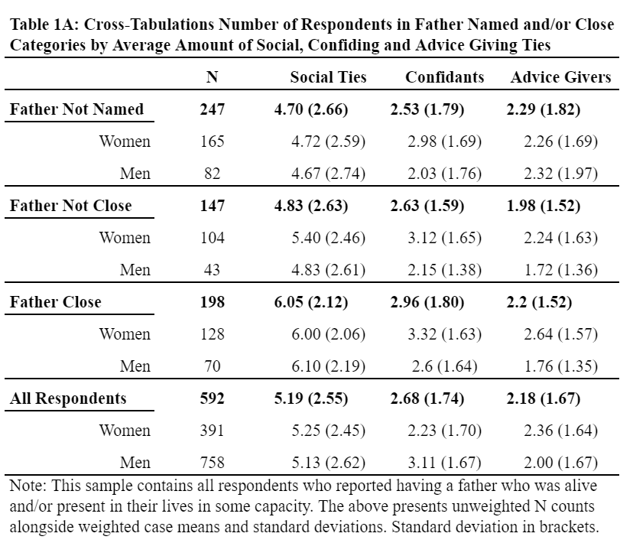

## **Results**

### Social Ties

When using all social ties as dependent variable, the close father variable was able to reject the null hypothesis in a test of overall variance. In the test of in-between subjects effects in SPSS General Linear Models, a close father was statistically significant to the < .01 level. That is, the model captured a significant amount of variance captured between the three categories of the close father variable. The close mother variable, on the other hand, failed to reject the null hypothesis in this test (*Table 2A, All Social Ties*).

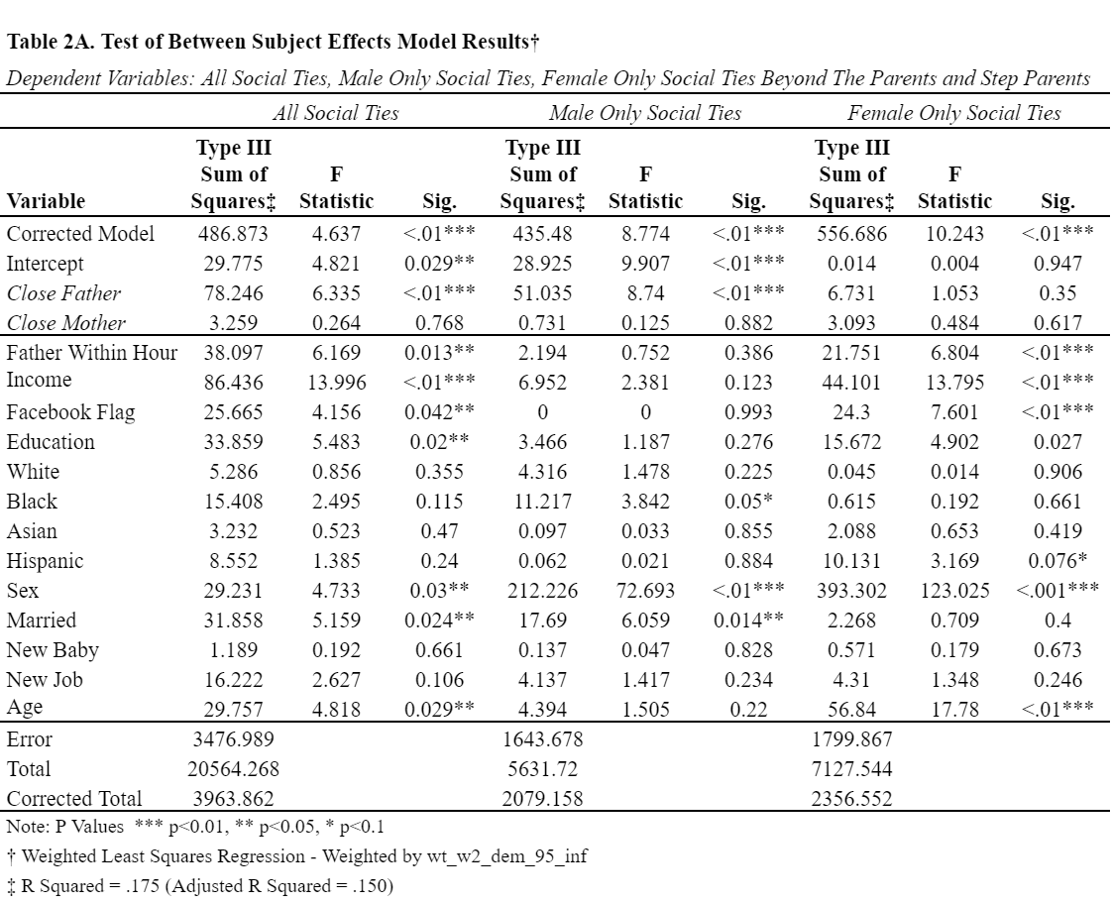

A similar outcome was found when using male only social ties as a dependent variable. The Close Father variable was, similarly, able to reject the null and with a p < .01 (*Table 2A, Male Only Social Ties*). However, the Close Father variable was not statistically significant when using female only social ties as a dependent variable; variance between the three categories within this variable were not significantly different (*Table 2A, Female Only Social Ties*). The Close Mother variable did not produce a significant amount of variance between categories in any of these models.

When observing pairwise comparisons, the three “social ties” models revealed that just naming a father within the network is *not* associated with a higher number of social ties reported by respondents. The category of people who named a father but did not consider him close was not significant in relation to those who didn’t name a father in any of these models. Further, these comparisons revealed that the close father category in relation to non-close fathers was statistically significant to the .049 level and a relatively large beta. For reference, females, generally, reported having .458 more social ties than men-- smaller than the .628 difference between a close father and a non-close father. That is, respondents report having significantly more social ties when they report a subjectively close father in comparison to those who name a father but do not consider him “close.”A close mother, again, did not produce any significant results (*Table 2B, All Social Ties*).

When observing a count of only *male* social ties, beyond the father and/or step father, a “close” father was more strongly significant, both statistically and in terms of size of beta. The category of people who named a close father had an average of .667 more male social ties with a statistical significance of <.01 (*Table 2B, Male Only Social Ties*). However, when observing a count of all *female* social ties (*Table 2B, Female Social Ties*), neither the presence or closeness the father produced any significant result in comparison to those who did not name a father at all. That is, a close father is associated only with a higher count of male social ties but not female ones.

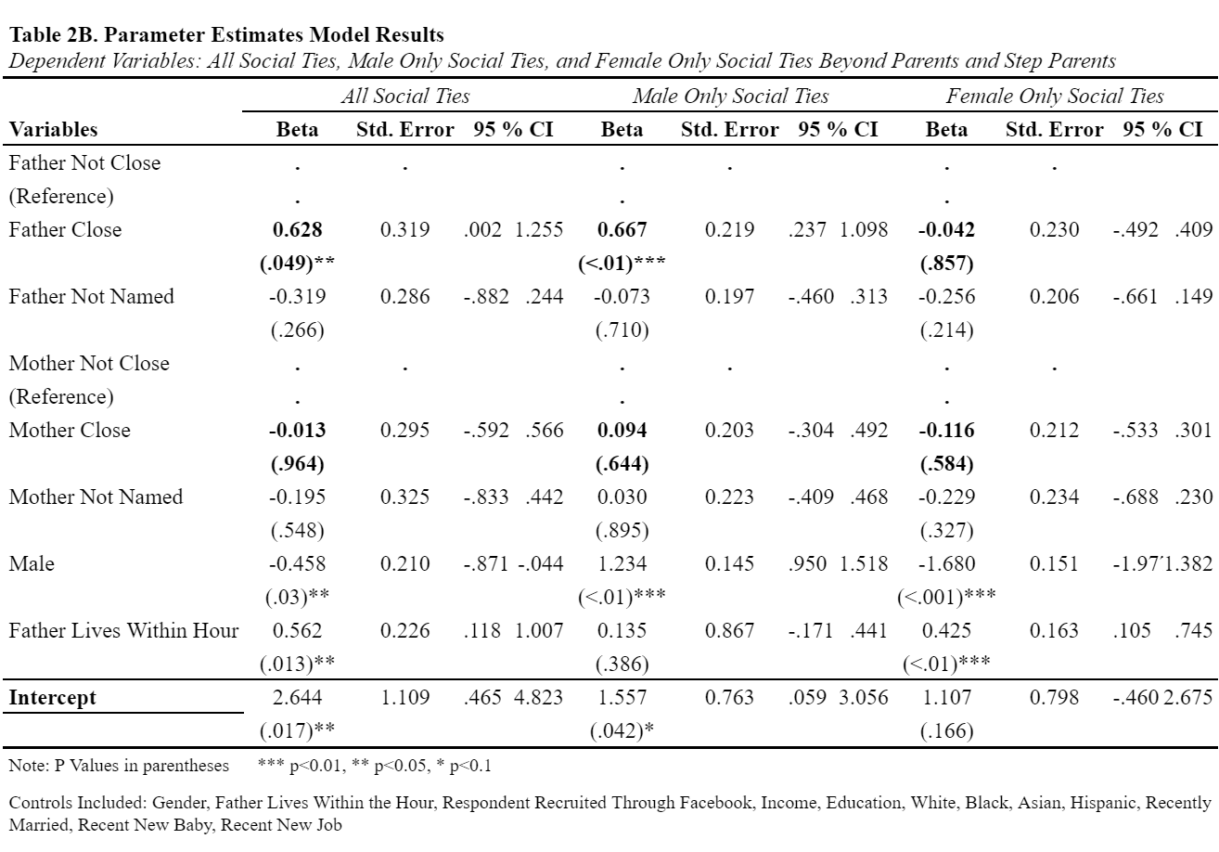

### Supportive Ties

The Close Father Variable failed to reject the null in a model using all of the respondent’s named confidants as a dependent variable; no significant variation was found between the three father categories in the test of in-between effects (*Table 3A, All Confidant Ties*). However, when we use male-only confidants as a dependent variable, we find that the categories within the Close Father variable do significantly vary, p < .01. This finding is consistent with previously mentioned results on social ties. Not consistent with the previous set of models, however, is the Close Mother variable, which also produced statistically significant results in the male only confidants model test for in-between effects (*Table 3A, Male Only Confidants*). Lastly, the Close Father variable did not produce a significant variation between categories when using female only confidants as a dependent variable, but a the Close Mother variable did (*Table 3A, Female Only Confidant Ties*).

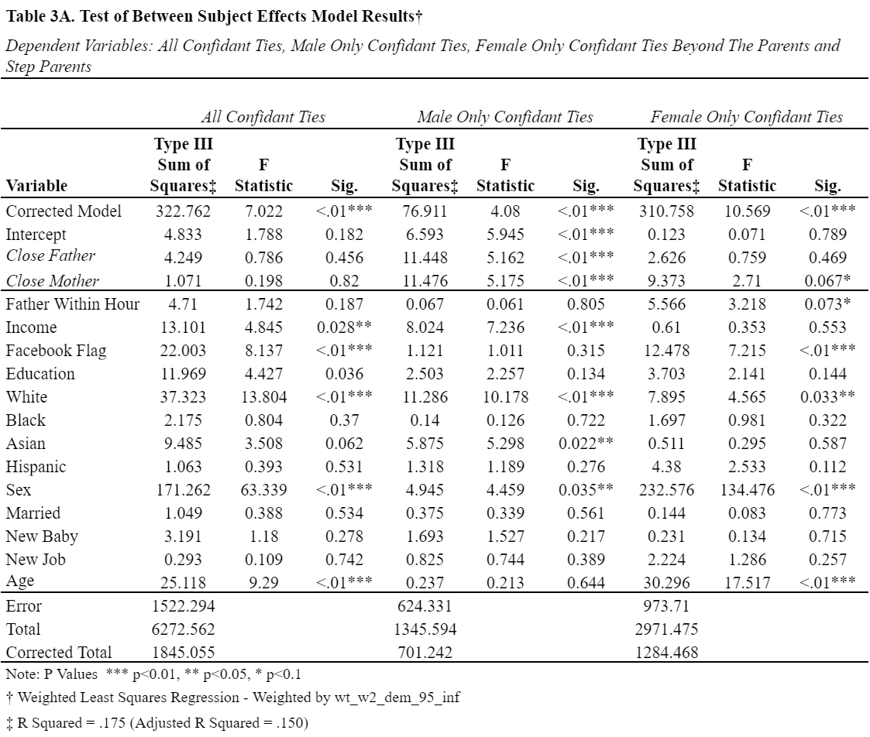

Unlike with social ties, parameter estimates revealed a close father was not strongly associated with having more people to confide in, in general (Table 3B, All Confidant Ties). However, like with social ties, a close father was associated with significantly more male confidants in comparison to people who named a father but did not consider him close. This outcome suggests that beyond presence or distance within the father, subjective closeness is associated with more males to confide in (*Table 3B, Male Only Confidant Ties*).

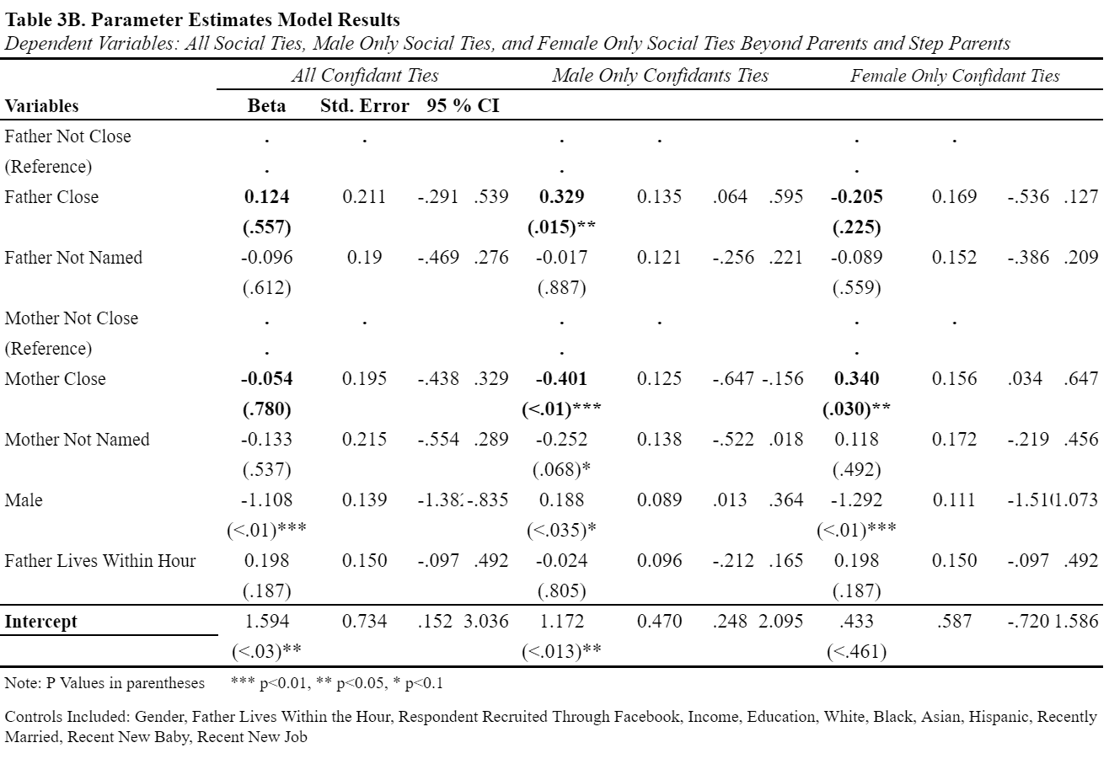

Consistent with previous findings on the father, a close mother produced significant results in its association with more *female* ties. Respondents who named a mother they felt especially close to had an average of .340 more females to confide in. This finding was statistically significant with a .03 P value. A close father, in this model, produced no significant results (*Table 3B, Female Only Confidant Ties*).

Surprisingly, respondent who named a mother they felt especially close to tended to name significantly less male social ties in comparison to respondents who named a mother but did not consider her close. These parameter estimates revealed not just a statistically significant result, with a less than 1% chance of being statistical noise, but also a relatively large beta of -.401. Less strongly, however, was the category of people who did not name a mother at all. These people also tended to have less males to confide in relative to people who named a mother they did not feel especially close to— this comparison produced a marginally significant .068 P value. That is, respondents who named a mother they did not feel especially close to were more likely to name a higher number of males to confide in (*Table 3B, Male Only Confidant Ties*).

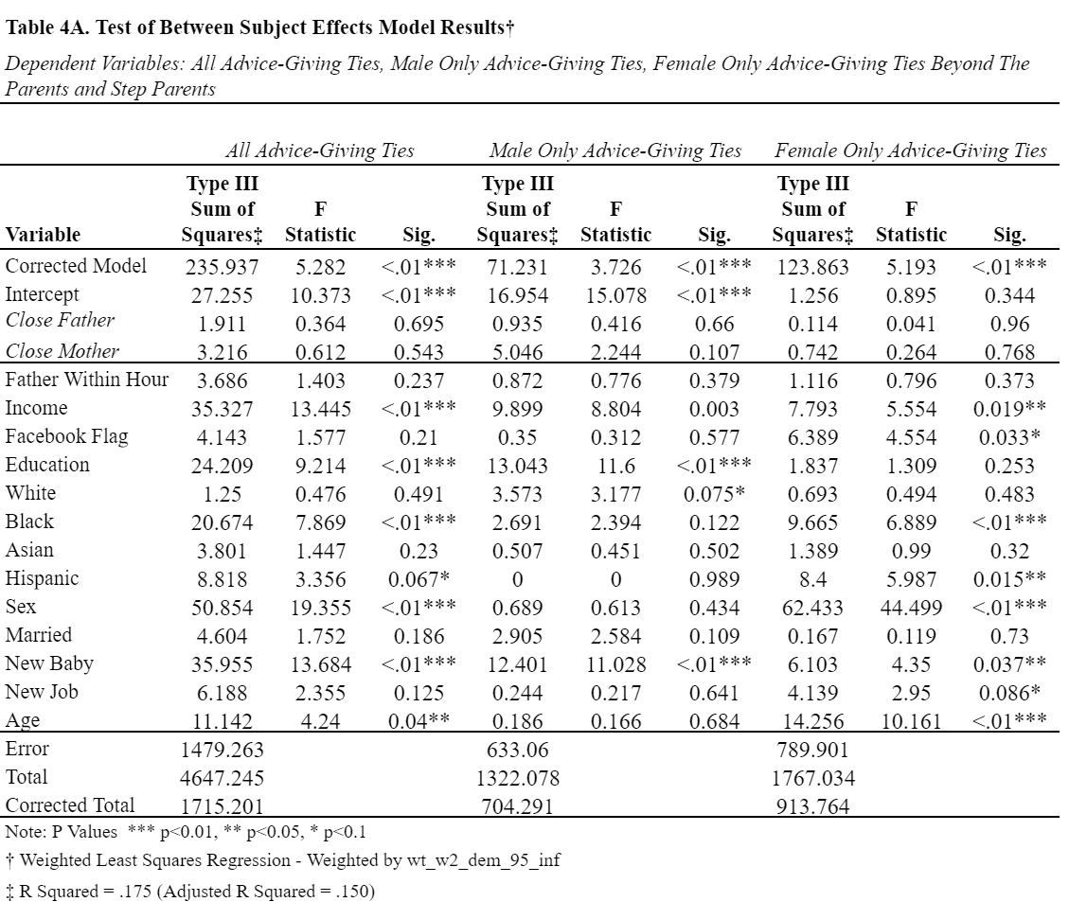

When using advice giving alters as an outcome, neither the Close Father or Close Mother variables were able to reject the null in terms of variation between their respective categories (*Table 4A, All Advice-Giving Ties*). I found the same outcome when using gender specific advice-giving dependent variables (*Table 4A, Male Only Advice-Giving Ties and Female Only Advice-Giving Ties*). Essentially, the presence of a father does not seem to influence the number of advice-giving whatsoever.

Although overall variation between the three categories of the Close Mother variable were not statistically significant, A closer look at the Close Mother Variable in pairwise comparisons revealed that respondents who named a close mother had fewer males to ask for advice. As with male confidants, respondents who named a mother they did not feel close to were likely to have more males to seek advice from. The comparison was, however, only marginally significant with a .068 p value.

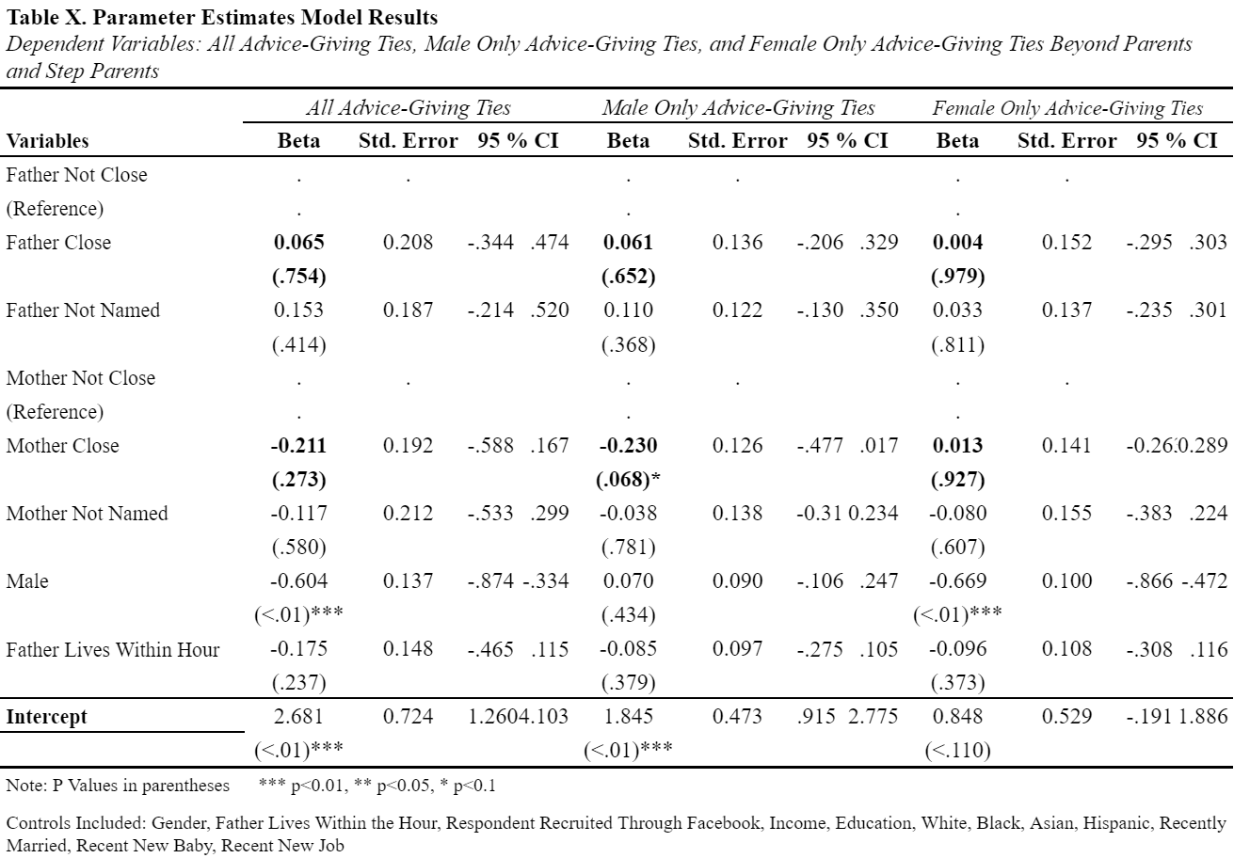

## **Discussion**

Those who name a father in their network do not have significantly more social ties than those who don’t. However, those who have a “close” father are likely to name more social ties relative to those who name him but don’t consider him “close.” Further, respondents who have a “close” father tend to have more *males* in their list of reported people they engage in social activities with, but *not* females. Although these models were designed primarily around the father (we selected for respondents who had father alive and controlled for whether the father lived within an hour) these outcomes unique relative to mother variables. That is, a close mother was not associated with a higher count of social ties at all.

Results using social ties as an outcome were very similar to results using confidants as an outcome. The presence of a “close” father is associated with a higher number of males available to confide in, but not females. Why would it be the case that a father’s presence is associated with a greater number of alters named for social activity and support? Further, why would it be that it’s mostly the number of *males* his closeness is associated with?

Although the cross-sectional nature of our findings limits our conclusions, what’s clear is that there is a positive association between the subjective closeness of a father in a respondent’s reported life and a higher count of other people available to confide and socialize with, even when we control for the father’s presence and physical closeness to the respondent. Subjective closeness to the mother was also, surprisingly, associated with fewer male “supportive” ties, and more female “supportive” ties. Subjective closeness to a parent is, generally, associated with differences in size and quality of social network in adult respondents.

It’s difficult for me to imagine a scenario in which someone would be more likely to name a close father in their social network when they also have a higher number of other people they socialize with and confide in. It’s easier to grasp the possibility that the presence of the father is influencing the number of social ties a respondent has and thereby passing down parental community social capital. The finding that the presence of a father in an adult’s life may influence her social network is consistent with research carried out on children (Rubin, Sloman, 1984; Lavenda, Kestler-Peleg, 2018). However, further research is necessary in order to more concretely pin down the direction of this association.

Further, that the *positive* presence of a father is strongly associated with a higher count of social ties is consistent with the predictions of attachment theory (Bowlby, 1969, 1980, 1988) as well as with social capital theory (Coleman, 1988). Yet, if attachment theory was at play, we would expect to see the respondent’s social network to be *generally* more robust in association with a positive relationship with her father, not just in terms of more males. It’s more likely that a positive father relationship leads to him introducing adult respondents to more people in his social network (social capital), leading to more opportunities for adults to build a more robust social network. Also, the father may be passing down “gender specific” social capital; he’s introducing his children to his social network, which will more often be male than female (McPherson, Smith-Lovin, Cook, 2001).

I suspect, however, that there may be something more going on. If it were simply the father introducing his adult children to his homophilous social network, why then would physical closeness and presence not being associated with a higher number of males to socialize and confide in? After all, the father’s network is more likely to be physically near him; a subjectively close father is statistically significant even beyond physical distance from the father. I posit that the close father passes down social capital in the form of *social skills* that are useful for generating more male social ties, as well as the desire to generate more male social ties (a positive role model for male interaction).

And, in support of the essential father hypothesis, father closeness often produces *unique* outcomes relative to mother closeness. For example, a close father is associated with a higher number of male social ties whereas a close mother is not. In fact, my models repeatedly uncovered that respondents, of both sexes, will tend to have a higher count of male ties in their networks even after all controls and parental variables are included. If fathers were not “essential,” associations between a “close” father and social network size and composition would be the same as a “close” mother.

It’s possible that fathers generate unique forms of social capital due to their gender role, their parental status, as well as how both of these things integrate themselves into the context of society. That is, gender roles often dictate the acceptability of how “close” a male is to get to others and how that closeness should manifest itself (Floyd, Morman, 1997; Swain, 1989; Wood, Inman, 1993). Furthermore, previous research has identified that men are often unwilling or unable to communicate affection with their own children even when they’re emotionally close (Morman, Floyd, 1999). In other words, that fathers communicate closeness in a different way could, potentially, explain why their closeness results in unique outcomes relative to mother closeness.

And so, that the classification as a father or mother as “close” creates some limitations for our understanding. As Bowlby said, “A feature of attachment behaviour of the greatest importance...is the intensity of the emotion that accompanies it…” (Bowlby, 1988). That is, without a deeper understanding of how respondents subjectively define “close,” and how intense they feel this emotion, it’s difficult to pin down what exactly may be causing this association. For example, might it be that some people have a higher threshold for what is to be considered close? Further, is it possible that different expectations of “closeness” from a father versus a mother affect a respondent’s labeling them as such?

Regardless, I’ve identified that the association between a close father, much like in children, with a more robust social network in adults is there even when controlling for things like how educated she is, her income, whether she’s gone through network altering life events, and the non-subjectively close presence. More research is required in order to find out which of my proposed explanations for why this is the case are most accurate. However, this study could be considered an important step in attempting to answer these questions.

## **VIII. References**

Amato, Paul R. “Father-Child Relations, Mother-Child Relations, and Offspring Psychological Well-Being in Early Adulthood.” *Journal of Marriage and the Family*, vol. 56, no. 4, 1994, p. 1031., doi:10.2307/353611.

Amato, Paul. “Paternal Involvement and Children's Behavior Problems.” *Journal of Marriage and Family*, vol. 61, no. 2, 1999, pp. 375–384., doi:10.2307/353755.

Barnett, Rosalind C, et al. “Men’s Multiple Roles and Their Rela-Tionship to Men’s Psychological Distress.” *Journal of Marriage and Family*, vol. 54, no. 2, May 1992, pp. 358–367., doi:10.2307/353067.

Belsky, Jay, et al. “Assessing Performance, Competence, and Executive Capacity in Infant Play: Relations to Home Environment and Security of Attachment.” *Developmental Psychology*, vol. 20, no. 3, 1984, pp. 406–417., doi:10.1037/0012-1649.20.3.406.

Biblarz, Timothy J., and Adrian E. Raftery. “Family Structure, Educational Attainment, and Socioeconomic Success: Rethinking the ‘Pathology of Matriarchy.’” *American Journal of Sociology*, vol. 105, no. 2, 1999, pp. 321–365., doi:10.1086/210314.

Bowlby, John. *Attachment and Loss*. Vol. 1, Hogarth Press, 1969.

Bowlby, John. *Attachment and Loss. Loss Sadness and Depression.* Vol. 3, Pimlico, 1980.

Bowlby, John. *Secure Base: Clinical Applications of Attachment Theory / John Bowlby*. 1988.

Brown, William H., et al. “Social and Environmental Factors Associated With Preschoolers’ Nonsedentary Physical Activity.” *Child Development*, vol. 80, no. 1, 2009, pp. 45–58., doi:10.1111/j.1467-8624.2008.01245.x.

Coleman, James S. *Social Capital in the Creation of Human Capital*. University of Chicago Press, 1988.

Entwisle, Doris R., and Nan Marie Astone. “Some Practical Guidelines for Measuring Youths Race/Ethnicity and Socioeconomic Status.” *Child Development*, vol. 65, no. 6, 1994, p. 1521., doi:10.2307/1131278.

Floyd, Kory, and Mark T. Morman. “Affectionate Communication in Nonromantic Relationships: Influences of Communicator, Relational, and Contextual Factors.” *Western Journal of Communication*, vol. 61, no. 3, 1997, pp. 279–298., doi:10.1080/10570319709374578.

Floyd, Kory, et al. “Human Affection Exchange: VI. Further Tests of Reproductive Probability as a Predictor of Mens Affection With Their Adult Sons.” *The Journal of Social Psychology*, vol. 144, no. 2, 2004, pp. 191–206., doi:10.3200/socp.144.2.191-206.

Fraley, R. Chris, and Phillip R. Shaver. “Adult Romantic Attachment: Theoretical Developments, Emerging Controversies, and Unanswered Questions.” *Review of General Psychology*, vol. 4, no. 2, 2000, pp. 132–154., doi:10.1037//1089-2680.4.2.132.

Fraley, R. Chris. “Attachment Stability From Infancy to Adulthood: Meta-Analysis and Dynamic Modeling of Developmental Mechanisms.” *Personality and Social Psychology Review*, vol. 6, no. 2, 2002, pp. 123–151., doi:10.1207/s15327957pspr0602_03.

Gerstel, Naomi, and Natalia Sarkisian. “Marriage: The Good, the Bad, and the Greedy.” *American Sociological Association*, vol. 5, no. 4, Nov. 2006, pp. 16–21., doi:https://doi.org/10.1525/ctx.2006.5.4.16.

Guiaux, Maurice, et al. “Changes in Contact and Support Exchange in Personal Networks after Widowhood.” *Personal Relationships*, vol. 14, no. 3, 2007, pp. 457–473., doi:10.1111/j.1475-6811.2007.00165.x.

Hannighofer, Jasmin, et al. “Impact of Relationship Status and Quality (Family Type) on the Mental Health of Mothers and Their Children: A 10-Year Longitudinal Study.” *Frontiers in Psychiatry*, vol. 8, 2017, doi:10.3389/fpsyt.2017.00266.

Hazan, Cindy, and Phillip Shaver. “Romantic Love Conceptualized as an Attachment Process.” *Journal of Personality and Social Psychology*, vol. 52, no. 3, 1987, pp. 511–524., doi:10.1037//0022-3514.52.3.511.

Kalmijn, Matthijs, and Paul M. De Graaf. “Life Course Changes of Children and Well-Being of Parents.” *Journal of Marriage and Family*, vol. 74, no. 2, 2012, pp. 269–280., doi:10.1111/j.1741-3737.2012.00961.x.

King, Valarie, et al. “Factors Associated with Positive Relationships between Stepfathers and Adolescent Stepchildren.” *Social Science Research*, vol. 47, 2014, pp. 16–29., doi:10.1016/j.ssresearch.2014.03.010.

Lamb, Michael E. *The Role of the Father in Child Development*. Wiley, 2010.

Lavenda, Osnat, and Miri Kestler-Peleg. “Intergenerational Transmission of Sociability: The Mediating Role of Maternal Competence and Maternal Child-Centrism.” *Journal of Family Issues*, vol. 39, no. 6, 2017, pp. 1664–1684., doi:10.1177/0192513x17720759.

Long, Edgar C. J., et al. “Memorable Experiences Between Fathers and Sons: Stories That Shape a Sons Identity and Perspective of His Father.” *The Journal of Mens Studies*, vol. 22, no. 2, Apr. 2014, pp. 122–139., doi:10.3149/jms.2202.122.

Mattanah, Jonathan F., et al. “The Contributions of Parental Attachment Bonds to College Student Development and Adjustment: A Meta-Analytic Review.” *Journal of Counseling Psychology*, vol. 58, no. 4, 2011, pp. 565–596., doi:10.1037/a0024635.

McPherson, Miller, et al. “Birds of a Feather: Homophily in Social Networks.”  *Annual Review of Sociology*, vol. 27, Aug. 2001, pp. 415–444., doi:https://doi.org/10.1146/annurev.soc.27.1.415.

Morman, Mark T., and Kory Floyd. “Affectionate Communication between Fathers and Young Adult Sons: Individual‐and Relational‐Level Correlates.” *Communication Studies*, vol. 50, no. 4, 1999, pp. 294–309., doi:10.1080/10510979909388501.

Offer, Shira, and Claude S. Fischer. “Difficult People: Who Is Perceived to Be Demanding in Personal Networks and Why Are They There?” *American Sociological Review*, vol. 83, no. 1, 2017, pp. 111–142., doi:10.1177/0003122417737951.

Palkovitz, Rob. “Involved Fathering and Men's Adult Development: Provisional Balances.” *Involved Fathering and Men's Adult Development: Provisional Balances*, 2002, doi:10.4324/9781410613059.

Pleck, Joseph H, and Brian P Masciadrelli. “Paternal Involvement by U.S. Residential Fathers: Levels, Sources, and Consequences.” *The Role of the Father in Child Development*, 2004, pp. 222–271.

Pleck, Joseph H. “Why Could Father Involvement Benefit Children? Theoretical Perspectives.” *Applied Developmental Science*, vol. 11, no. 4, 2007, pp. 196–202., doi:10.1080/10888690701762068.

Portu-Zapirain, Nerea. “Attachment Relationships with Fathers and Mothers during Early Chilhood.” *Psychology*, vol. 04, no. 03, 2013, pp. 254–260., doi:10.4236/psych.2013.43a038.

Rubin, Zick, and Jone Sloman. “How Parents Influence Their Children’s Friendships.” *Beyond The Dyad*, 1984, pp. 223–250., doi:10.1007/978-1-4757-9415-1_10.

Sharabany, Ruth, et al. “Like Fathers, Like Sons? Fathers Attitudes to Childrearing in Light of Their Perceived Relationships with Own Parents, and Their Attachment Concerns.” *Parenting Representations*, pp. 239–262., doi:10.1017/cbo9780511499869.009.

Swain, Scott O. “Covert Intimacy: Closeness in Men’s Friendships.” *Gender in Intimate Relationships*, 1989, pp. 71–86.

Wood, Julia T., and Christopher C. Inman. “In a Different Mode: Masculine Styles of Communicating Closeness.” *Journal of Applied Communication Research*, vol. 21, no. 3, 1993, pp. 279–295., doi:10.1080/00909889309365372.